Viborg-Hurley Science Curriculum Handbook
Est. 2020 by Camron Groenke

Middle School Progressions

7th Grade
- Units Covered
  - Metric Units and Conversions
  - Molecules to Organisms: Cell structures and Processes / Body Systems
  - Heredity and Genetic Variation
  - Sexual and Asexual Reproduction
  - Ecosystems: Interactions / movement of energy

8th Grade
- Units Covered
  - Metric Units and Conversions
  - Matter and Interactions
    - Periodic Table basics
    - Bohr Diagram
    - Electron configurations
    - Simple Chemical Formulas
  - Motion and Force Interactions
    - Particle motion
    - Newton’s Three Laws
  - Energy: Sound and Light Waves
    - Electromagnetic Spectrum
    - Potential and Kinetic energies

High School Progressions

Freshmen Year
- Class: Biology (further breakdowns in Curriculum Maps)
  - Units Covered
    - Metric Review and Process of Science Review
    - Chemistry of Life
      - Reactions, Bonding, Water, pH, and Organic Compounds
    - Biodiversity
      - Taxonomy, Cladistics, and Phylogeny
      - Animal Kingdoms
    - Ecology
      - Principles of Ecology
      - Climate and Weather / Climate Change
      - Population Growth
      - Community Interactions
      - Ecosystems and Energy Flow / Succession
    - Cell Structure and Function
      - Organelles and Functions
      - Processes of the Cell
      - Cellular Division and Cancer
    - Heredity and Genetics
      - Inheritance
      - Chromosome Structure
      - Gene Structure
      - DNA Duplication, Transcription, and Translation.
    - Evolution
      - Darwin’s Journey
      - Evidence of Evolution
      - Mechanisms of Evolution
      - Speciation
Sophomore Year
- Class: Physical Sciences (further breakdowns in Curriculum Maps)
  - Units Covered
    - Process of Science
    - Metric Review and Conversions
    - Motion and Force Interactions
    - Work and Energy
    - Thermal Energy
    - Electricity and Magnetism
    - Waves and Wave Interactions
    - Matter and Fluids
    - Matter and Elements
    - Chemical Bonds
    - Chemical Reactions and Radioactivity
    - Solutions
    - Earth Processes and Materials
    - Astronomy

Junior / Senior Year

- Viborg Hurley requires 3 lab science credits to graduate. Students have an option of classes to take that fits their high school and post high school career plans. Breakdowns of topics covered are further broken down in curriculum maps of each class.
- Classes offered:
  - Chemistry / Physics (1 year cycle) *Chemistry and Physics are offered every other year, opposite of each other.
  - Anatomy and Physiology
  - Earth Science
  - Forensic Science (Taught by Mr. Johnson in 2022-2023)
  - STEM (Science, Technology, Engineering, Art, and Math)
  - Zoology (can be offered, but typically is not offered as a regular class offering)

*Junior/Senior grades are also based off of formative and summative assessments, but will be weighted 35% and 65% respectively. The emphasis of these upper level classes will be for students to prepare academically for summative based assessments.

Science Curriculum Foundations

- The Viborg Hurley Science Curriculum is structured based on the recommendations of the Next Generation Science Standards, STEM Education, and the State of South Dakota Science Standards.

- The following concepts outline the direction and goals of the Viborg Hurley Science Education Department:

  - Three Spheres of Science
    - Investigation
    - Evaluation
    - Developing Explanations and Solutions

  - Crosscutting Concepts (concepts that are essential to multiple disciplines of science)
    - Identifying Patterns
    - Cause and Effect Relationships
    - Scale, Proportions, and Quantities
    - System and System Models
    - Energy and Matter Cycling and Conservation
    - Structure and Function
    - Stability and Change
    - Applications of Technology

  - Four Strands of Science Proficiency
    - Knowing, using, and interpreting scientific explanations of the natural world.
    - Generating and evaluating scientific evidence and explanations.
    - Participating productively in scientific practices and discourse.
    - Understanding the nature and development of scientific knowledge.

Mr. Groenke’s Syllabus (Updated 2022-2023)

Course Title: Science

Class Description: My belief as a teacher is to inspire and challenge all students to be the best that they can be in whatever they do. I do not believe in “taking the easy route” and I will not alter my expectations. Laziness and lack of respect are not tolerated in my room because I believe in a productive and safe classroom. We will be exploring the world of science and there will be challenging aspects of my classes. Science is not always easy so you must be prepared to come to my class and work to be a better student. We will explore a variety of topics from both audio, visual, and hands-on applications. Do not be afraid to ask questions or come see me with concerns, but all I ask is that you bring yourself, bring a good work ethic, and we will have a successful year.

Teacher: Mr. Camron Groenke
- Email: Camron.groenke@k12.sd.us Check Daily from 7:45 to 8:30 am.
- Open classroom hours: 2nd Hour SH, 5B , before school 7:30-8:00 am, or after school 3:45-4:00 pm. (Not available after school from Nov-Feb due to wrestling)
- Website: https://mrgscienceclassroom.weebly.com/

Course Materials: a. Textbook (if applicable)
b. Something to organize class materials (Binder, Folder, Online Portfolio, etc.)
c. Something to write on (paper, notebook, etc.)
d. Something to write with (pencil, pen, etc.)
e. Lab notebook and other materials specific to future assignments
*All school materials will be properly used and handled with care. Any misuse of the equipment will result in loss of the privilege for the rest of the time, appropriate consequences, and a retraining session. Any damaged or lost items must be replaced via the student who had possession!

Student Assessment Portfolios
- All Viborg Hurley students taking a science class will be required to complete a student assessment portfolio as their yearly final to demonstrate their academic growth and connect to their learning goals. (Learning goals will be set by students at the start of the academic year)
- SAPs vary based on grade level and should reflect student understanding and growth through their given curriculum.
- All SAPs MUST follow the following format:
  - Cover Page
  - Table of Contents
  - Student Contract
  - Student Learning (9th and 10th) or Mastery (11th and 12th) Artifacts
  - Reflection Paper (9th), Science Fair Project (10th), or Cumulative Artifact (11th and 12th)
- Goal of SAPs
  - Provide students a method of demonstrating their understanding of multiple concepts as well as defending their learning and growth throughout the academic year by providing and explaining multiple learning artifacts.
  - Allow students an opportunity to demonstrate real world opportunities and connections using science.
  - Develop organizational and time management skills as they should maintain their SAPs throughout the school year.
  - Will serve as spring semester finals and serve as 15% of final semester grade.
Class Goals:
- Teach students practical scientific skills, which they can use to investigate, study, and explain the world around them.
- Create learning that should be challenging yet engineered to create an exciting learning environment in which science is fun and related to each of your everyday lives.
- Enhance critical thinking skills and reflect student interests and questions.

Student and Teacher Behaviors

Classroom behavior
Students will treat each other with respect and work together without any conflicts. If any conflicts do arise please make sure to ask for my assistance and we will develop a plan to effectively address the issue. I hope everyone can make each other feel safe and confident to fully participate in class in front of their peers.

When entering and exiting the room, remain respectful and be quiet and orderly. Take your assigned seat and immediately begin on the bellringer and copy down the objective and agenda for the day. Cell phones are NOT allowed in my class and if found they will be confiscated until the end of day and you will be subject to a retraining session. During instruction or class discussion please be respectful to others and do not interrupt or talk while others are talking. Violation will result in retraining as well.

Substitute Teacher Behavior Expectations
I expect everyone to treat the substitute teacher with the dignity and respect we hold in our classroom at all times. Even though I am gone, I do not expect our classroom beliefs to change. If any problems do arise, the sub will fill out a behavior report form to leave for myself and the office. I will call the sub after the school day to investigate how the day went. Any misbehavior will be dealt with through retraining and an action plan meeting.

Cheating
Cheating is a form of disrespect that will not be tolerated in this classroom. Plagiarism is considered a form of cheating as well. Cheating shows disrespect to me because you believe the test, project, or assignment was not worth your time or effort. It also shows disrespect for yourself and others because you do not value your own education and you are taking advantage of other people’s hard work. Cheating will require appropriate action and consequences. Possible conferences with parents will be held to discuss the situation. Retraining WILL occur following any form of cheating. ALL TESTS WILL REQUIRE YOU TO PLACE CELL PHONES IN THE BASKET UNTIL FINISHED. TALKING DURING TESTS WILL ALSO RESULT IN AUTOMATIC FORFEIT OF YOUR TEST.

Retraining
Retraining results from any misbehavior, misuse of equipment, or incompetence with school or classroom procedures. Retraining MUST be completed with me at a time that is convenient to you, the student. Retraining will continue until the correct behavior is accomplished.
*1 warning will be given for misbehavior, retraining will occur on the student’s time.

Late Policy
- I will only accept late assignments up to 3 days late for which you are docked 10% per day. Weekends count as one day, Fridays still count as one day. Following the three days, any assignment is an automatic zero. If you know you will be gone when an assignment is assigned or when it is due, it is your responsibility to make arrangements to avoid late points.

Assignments

- Assignments will always be relevant to the material being studied and will be given out fairly to each individual student. Choices may be given over what option of homework to be completed and what days homework will be given out to the students.
- Points typically vary from 10-30 points per assignment.
- Homework MUST be completed and turned in to the hand-in box at the beginning of class on each due date. If this cannot be done, you may contact me BEFORE the due date to discuss an appropriate plan of action during any of my open hours.
- If assignments are incomplete or not turned in, see late policy above. I will not accept incomplete assignments.
- Reading assignments should be completed by the due date provided and students should be prepared to discuss the reading in class.
- Major projects will be given each quarter. Status reports will be given to gauge how far along each student is to ensure the successful completion of the projects. Any concerns that arise during the course of these projects may be directed to me and appropriate plans will be made.

Science Literacy
- To improve science comprehension and literacy you will research and complete one podcast episode per semester (11th and 12th) or listen and recap a science based podcast episode (9th and 10th) as a team. The podcast episode must be between 10-15 minutes in length. It is the student’s responsibility to pick a topic relating to science, but driven by their interests. The episode must be professional and carefully planned. The audio file or paper will be uploaded to the labeled Drive folder on the final day of each quarter. Reviews are 20 points and episodes are 30 points. MUST be referenced.
- Due Dates are the week prior to semester tests each semester, but can be submitted at any time during the semester.
- We will also complete science talks bi-weekly as a whole group. These will be recorded as a group for the podcast as well in an effort to actively discuss what we are doing in the classroom and recap our learning process.

Attendance

Attendance is crucial to the success of my class. Class discussions will occur daily and is very important you are present and participate each day. Daily attendance and participation will account for a small percentage of your final grade in my class.

If you know that you will be absent, you need to make the appropriate arrangements with me BEFORE the day you will be gone. It is important to get all of the assignments and materials that you will need so that you are not left behind when you return. If you have an unplanned absence you need to contact me as soon as you return so that you can get any of the material or assignments you missed. It is not my responsibility to get you caught up, it is YOUR responsibility and I will hold you accountable.

If you are tardy to my class you must have a pass from another teacher, administrator, or staff. If you do not have a pass you will be marked tardy and that will result in a retraining session when you are available.

Grading Procedure
Viborg-Hurley grading scale is as follows:
- A= 93% and above
- B= 86-92%
- C= 78-85%
- D= 70-77%
- F= Less than 70%
**Note that effective the 21-22 school year, upper level class grading will be broken into two categories. Formative assessments (bellringers, labs, homework, projects) will account for 40% of your grade. Summative assessments (quizzes and tests) will account for 60% of your grade. Freshmen and sophomore classes will still maintain similar categories but will be graded on a points total.

Labs
- This class will involve a variety of labs that may involve dangerous equipment and/or chemicals. It is important to know lab safety and know how to use all safety equipment. Misbehavior will NOT be tolerated in the lab in an order to keep everyone safe and protected. ANY misbehavior will result in a conference with me and retraining will occur. (Please see lab safety contract)
- ALL LABS WILL CONSIST OF A WRITTEN LAB REPORT.

Emergency Situations
- All emergency protocols MUST be followed to ensure the safety of all students. Know proper safety procedures for fire drills, severe weather, intruders, lab accidents, etc. Follow all instructions by the teacher. Failure to do so could result in harm of fellow students and proper discipline will be sought for failure to follow procedures during an emergency situation.

Assessment Goals

Freshmen
- Assessments designed to reflect the knowledge and application of scientific content reflective of course goals.
  - Problem solving
  - Identifying patterns
  - Explanations of scientific concepts
  - Application and identification of correct scientific concepts.
- Course goal is 75% student success per assessment.

Sophomores
- Assessments designed to reflect the knowledge and application of scientific content reflective of course goals.
  - Problem solving
  - Identifying patterns and relationships
  - Explanations of scientific concepts
  - Use of previous content to solve current concept problems.
  - Application and identification of correct scientific concepts.
  - Evaluation of current scientific issues.
- Course goal is 80% student success per assessment.

Juniors/Seniors
- Assessments designed to reflect the knowledge and application of scientific content reflective of course goals.
  - Problem solving
  - Identifying patterns and relationships
  - Explanations of scientific concepts
  - Use of previous content to solve current concept problems.
  - Application and identification of correct scientific concepts.
  - Evaluation of current scientific issues.
  - Use of inquiry methods to solve complex problems.
  - Ability to defend answers to scientific questions using data, observations, and explanations.
  - Connecting structures and their related functions.
- Course goal is 85% student success per assessment.

Student Assessment Portfolios (SAPs)

- All Viborg Hurley students taking a science class will be required to complete a student assessment portfolio as their yearly final to demonstrate their academic growth and connect to their learning goals. (Learning goals will be set by students at the start of the academic year)
- SAPs vary based on grade level and should reflect student understanding and growth through their given curriculum.
- All SAPs MUST follow the following format:
  - Cover Page
  - Table of Contents
  - Student Contract
  - Student Learning (9th and 10th) or Mastery (11th and 12th) Artifacts
  - Reflection Paper (9th), Science Fair Project (10th), or Cumulative Artifact (11th and 12th)
- Goal of SAPs
  - Provide students a method of demonstrating their understanding of multiple concepts as well as defending their learning and growth throughout the academic year by providing and explaining multiple learning artifacts.
  - Allow students an opportunity to demonstrate real world opportunities and connections using science.
  - Develop organizational and time management skills as they should maintain their SAPs throughout the school year.

Freshmen SAPs Outline
- Cover Page
- Table of Contents
- Student Contract
- Student Learning Goals (3)
- Student Learning Artifacts
  - 5 artifacts
- Two page reflection paper (double spaced)
  - Outline what was learned, how they progressed, how they met their academic goals for the class, and how their artifacts reflect their growth.
  - Will present these in a booth type setting where judges can go around and discuss each portfolio with you.
Sophomore SAPs Outline
- Cover Page
- Table of Contents
- Student Contracts
- Student Learning Goals (5)
- Student Learning Artifacts
  - 7 artifacts
- Science Fair Project
  - Sophomores will be tasked with taking content from class and applying through the planning and completion of a science fair project complete with a visual display and written lab report for their final portion of the SAP. They must be original ideas and not just one copied from an online source. Can be done with a partner. Will share their final SAPs during finals day in a booth like setting for judges to visit and judge final projects.

Junior / Senior SAPS Outline
- Cover Page
- Table of Contents
- Student Contracts
- Student Learning Goals (7)
- Student Mastery Artifacts (Learning Artifacts for Earth Science)
  - Units vary by elective class.
  - Must have 10 artifacts
  - Provide a written description for the purpose of the artifacts. Don’t select them just because of the grade, they should represent your growth and confidence in aspects of the class. (5-10 sentences)
- Cumulative Artifact (Recommend having a topic by January…you must register this with Groenke by the second week of January with an outline.)
  - Students must complete a cumulative artifact for the class they are in. This can be done solo or with a partner. The cumulative artifact is an opportunity to go further in depth on a particular topic from the class. This cumulative artifact can look like a majority of things, but ultimately is an opportunity for you to be hands on and dig deeper into a topic! Examples include:
    - An advanced lab and lab report
    - Building a model, simulation, or digital platform to showcase a topic.
    - Community based project / research
    - Or any other ideas approved my Mr. Groenke. Note there are no research papers this year!
  - Must be prepared to PRESENT your cumulative artifact on semester test date. Will be graded on presentation skills and professionalism. If you wing it, you will fail. Treat this as a professional presentation of your work.
  - Sources must be referenced (both at the end and in text) in MLA format with at least five different sources.
- Q&A Session
  - Students must demonstrate their growth and understanding in their artifact topic. Must utilize at least two mastery artifacts as evidence of connection between the research topic and student learning goals.

Student Learning and Mastery Artifacts

- Student Learning Artifacts
  - Any student work from a unit that the students believes demonstrates their academic understanding of the content, as well as reflects progress towards their academic goals.
  - Must demonstrate a minimum score of 85% to be considered a student learning artifact.
  - Selections should be genuine and honest. Students will have to explain why this demonstrates their academic growth.
  - Examples of Artifacts
    - Homework
    - Projects or Pictures of Projects
    - Lab Reports
    - Papers
    - Reflections
    - Tests or Quizzes
    - Any other work not listed must be approved by the science educator.
  - Students are expected to maintain their artifact collection throughout the academic year so they may organize their SAPs during the final two weeks of school.
    - May be stored in a designated space within the science classroom.
- Student Mastery Artifacts
  - Any student work from a unit that the students believes demonstrates their academic understanding of the content, as well as reflects progress towards their academic goals.
  - Must demonstrate a minimum score of 90% to be considered a student mastery artifact.
  - Selections should be genuine and honest. Students will have to explain why this demonstrates their academic growth.
  - Examples of Artifacts
    - Homework
    - Projects or Pictures of Projects
    - Lab Reports
    - Papers
    - Reflections
    - Tests or Quizzes
    - Any other work not listed must be approved by the science educator.
  - Students are expected to maintain their artifact collection throughout the academic year so they may organize their SAPs during the final two weeks of school.
    - May be stored in a designated space within the science classroom.

Student Contracts (Copy)
Educational Contract

*Your signature signifies that you have read and understand the syllabus for Mr. Groenke’s Science Course and you understand the expectation of the Student Assessment Portfolio (SAP). Students are expected to identify academic goals, demonstrate academic growth, and participate in this class to the best of their abilities. Students agree to abide by the expectations and outlines set forth by Mr. Groenke and agree to the appropriate consequence of any given misconduct in the classroom. In addition, there will be subjective and graphic images in science curriculum if you have any concerns over this content you may contact me to discuss it. If you or your parents have any question please feel free to contact me so we can discuss them immediately. Thank you for your time and I look forward to a successful and fun year with everyone!

Student Name: ______________________

Students Signature: ___________________ Date:___________

Parents Name: _______________________

Parents Signature: ____________________ Date:___________

Parents Contact Information (If I need to contact you about your child):

Phone Number: _____________ Email:_______________

* I, as your teacher, will teach every student with dignity and respect. I will treat each of you fairly, but not equally. I will respect each of you and will not discuss other students with you, only matters that concern you. I promise that I will do everything that I can to help you succeed in this class. Feel free to come to me with any concerns or questions and I will be happy to assist you to the best of my abilities. Our classroom will be a place to facilitate learning and a place where everyone is treated with the respect they deserve. I will develop a classroom that is orderly, predictable, and safe for everyone. I plan to uphold the Viborg-Hurley school district mission, “Empowering our students to succeed in an ever changing world.”

Teacher Signature: _________________________

South Dakota State Science Standards

Physical Science Standards (Addressed in Physical Science, Chemistry/Physics, Environmental Science, Biology, and Forensics)

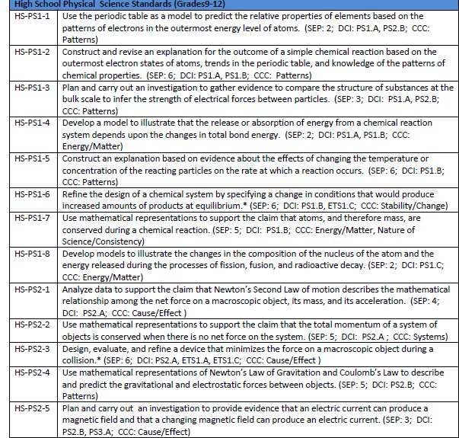
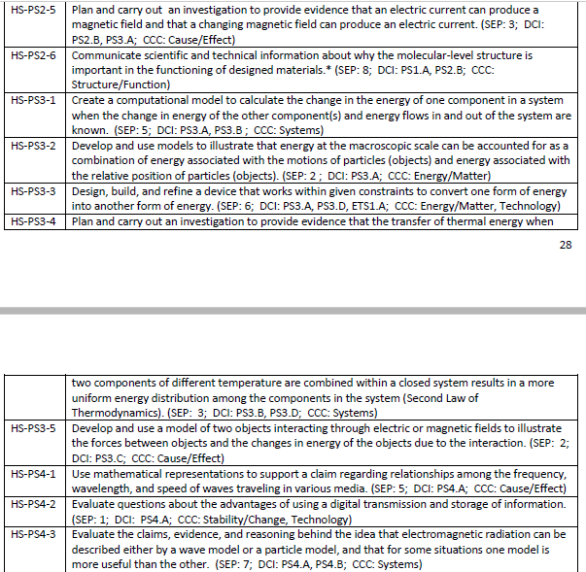
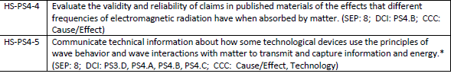

Life Science Standards (Addressed in Biology, Anatomy, Forensics, and Environmental Science)

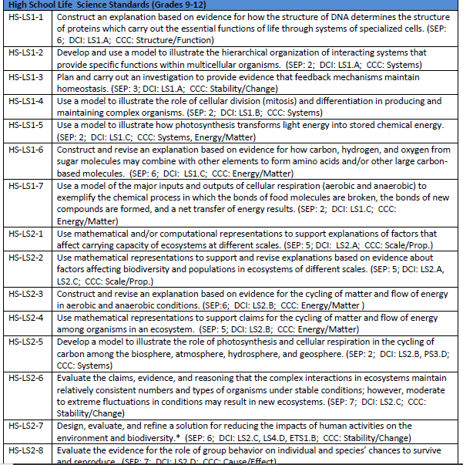
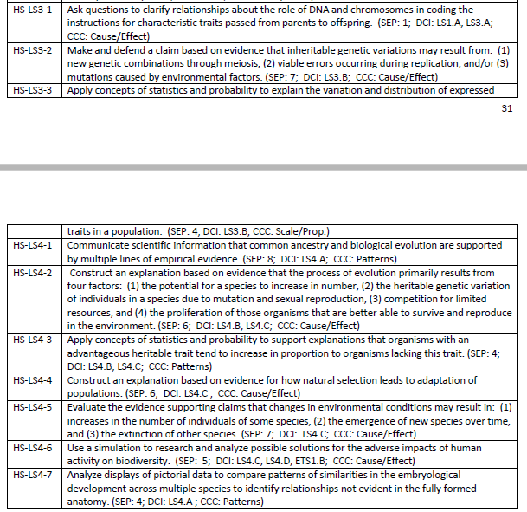

Earth Science Standards (Addressed in Physical Science and Environmental Science)
